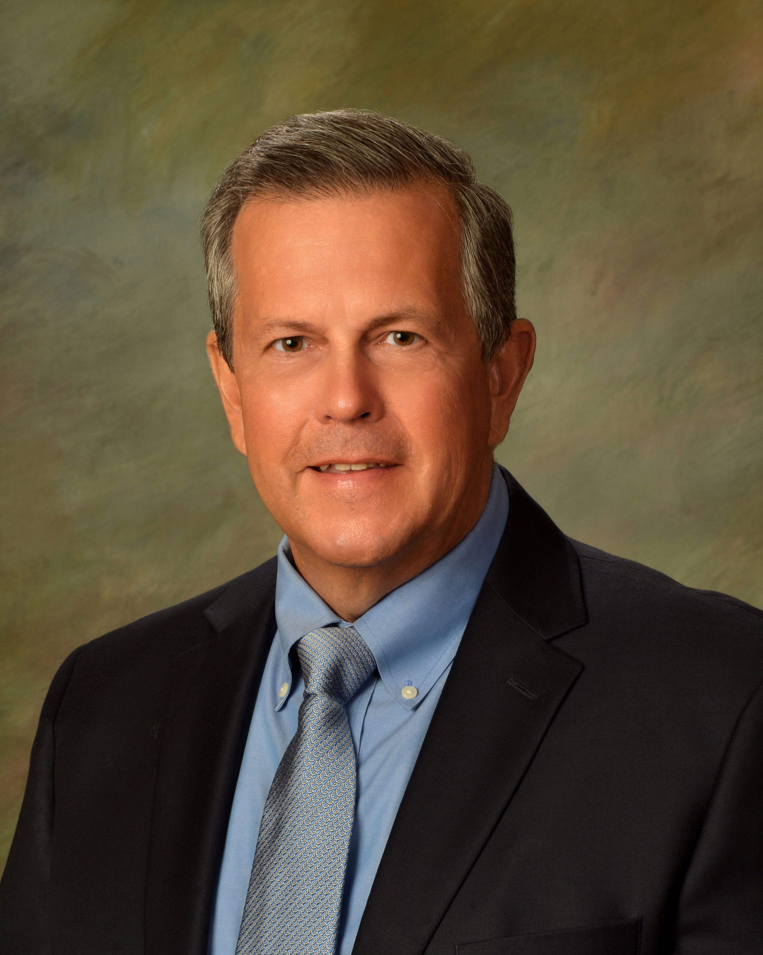

***Mark A. Rowley, M.D.***

***Fellow American Academy of Orthopaedic Surgeons***

***Myrtle Beach, South Carolina***

***(336) 906-9622***

[***markarowleymd@gmail.com***](mailto:markarowleymd@gmail.com)

***Summary of Qualifications***

Board-Certified Orthopaedic Surgeon specializing in adult reconstruction and trauma (ABOS certificate expires 2037).

Accomplished skills in knee and shoulder surgery, joint replacement, arthroscopic surgery and trauma.

Fellowship training at the Johns Hopkins School of Medicine.

Independent Medical Examiner.

Expert Case Reviewer with deposition and trial experience. Areas of interest – diagnosis and treatment of orthopaedic conditions, worker’s compensation, disability and orthopaedic implant product liability.

Expert Case Reviews have been completed for law firms, insurance companies, U.S. Department of Labor, U.S. Department of Justice, veterans and individuals.

Licensed in Virginia, North Carolina, South Carolina and Florida.

***Education and Professional Training***

1999-2000 The Johns Hopkins University School of Medicine- Fellowship in Adult Reconstruction and Joint Replacement.

1991-1995 Wake Forest University/Baptist Medical Center-Residency in Orthopaedic Surgery.

1990-1991 Wake Forest University/Baptist Medical Center-Internship in General Surgery.

1986-1990 M.D. Medical College of Virginia

***Professional Experience***

4/2019-present Tidelands Health with MUSC, Orthopaedic Surgery, Myrtle Beach, South Carolina

8/2004-present Roanoke, Virginia and Myrtle Beach, South Carolina -consultant and expert orthopaedic surgery case reviewer, occupational medicine, independent medical evaluations, work related injuries and return to work programs. Bridging the gap between healthcare and workplace disorders by integrating clinical, legal and insurance issues.

2/2012- 3/1/2019 Lewis Gale Medical Center, Salem, Virginia. LGMC is a tertiary, referral center for a multihospital system in Southwestern, Virginia. Top ranked facility by the Joint Commission and healthcare consumer organizations.

9/2013- 3/1/2019 Department of Surgery, Professional Practice Review at Lewis Gale Medical Center. Quality assurance committee reviewing outcomes of surgery and risk management.

2006-2012 Full time clinical practice. High Point Regional Hospital.

High Point, North Carolina.

2000-2006 Full time clinical practice. INOVA/Loudoun Hospital, Leesburg, Virginia. Reston Hospital, Reston, Virginia.

1995-1999 Full time clinical practice. High Point Regional Hospital.

High Point, North Carolina.

***Academic Appointments and Teaching Experience***

3/2012-present Virginia Tech/VCOM Assistant Professor

8/2015-2019 Roanoke College- Instructor in Anatomy and Physiology

8/2007-1/2012 Wake Forest University

8/2000-8/2006 Chatham University

8/1999-8/2000 The Johns Hopkins University School of Medicine- Department of Orthopaedic Surgery

***Publications***

2018 Fracture Reduction Instruments Used in Orthopaedic Trauma (video).

2017 Total Knee Arthroplasty Technique Manuel (video).

Reverse Shoulder Arthroplasty Technique Manuel (video).

2015 Cement Preparation Technique for Knee Arthroplasty (video).

***Professional Development***

2023 Surgical Insights: Taking Orthopaedic Trauma Call AAOS

BLS/ACLS

Against Medical Advice: Autonomy Versus Safety

2022 Southern Orthopaedic Association

2021 Prevention of Medical Errors

Controlled Substances Prescribing

Risk Management: Repairing Difficult Patient Relationships

2020 AAOS Adult Spine

AAOS Foot and Ankle

2019 IME Skills for Physicians: The Master’s Program

AAOS Adult Reconstructive Surgery of the Hip and Knee

AAOS Unstable Intertrochanteric Hip Repair with a Cephalomedullary Nail

Florida Medical Association: Preventing Medical Errors for Physicians

MedRisk: Risk Management- Failure to Diagnose

MedRisk: Risk Management Rounds- Orthopaedics

2018 AAOS Musculoskeletal Trauma

Orthopaedic Trauma Association Boot Camp

Orthopaedic Association Annual Meeting

Southern Orthopaedic Association Annual Meeting

2018 Florida Medical Association Opioid Summit: Responsible Prescribing.

2017 Gold Winner Best Bedside Manner, Southwestern, Virginia

***Professional Affiliations***

Diplomate, American Board of Orthopaedic Surgery

Fellow, The American Academy of Orthopaedic Surgeons

Southern Orthopaedic Association

American College of Occupational and Environmental Medicine

Florida Medical Association

Updated 6/10/2024