CURRICULUM VITAE
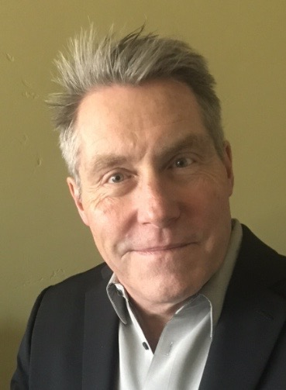

JOHN V. “JAY” FOLEY MD, FAAOS
230 Juniper Hill Road
Reno, NV 89519
Tel: (530) 412- 1680
Fax: (775) 409-3017
Cell: (530) 412-1680
E-mail: jay@jvfoleymd.com

EXPERTISE: ORTHOPEDIC SURGERY

- Board Certified in Orthopedic Surgery (ABOS: 1997-present)
- Sub-specialty Certified in Orthopedic Sports Medicine (ABOS: 2011-present)
- Fellow - American Academy of Orthopedic Surgery (FAAOS)
- Graduate: Harvard Orthopedic Training Program
- Chief Residency – Massachusetts General Hospital
- Sports Medicine Fellowship Trained
- Clinical Associate Professor-Community Faculty (2006-Current) – University of Nevada Reno School of Medicine (UNR-SOM)
- UNR-SOM Executive Admissions Committee Member
- California Qualified Medical Examiner (QME)
- Harvard College Graduate
- President: Truckee Surgery Center (2010-2019)

CURRENT HOSPITAL AFFILIATIONS and PRACTICE LOCATIONS:

TAHOE FOREST HOSPITAL
Tahoe Forest Hospital Orthopedics and Sports Medicine
Truckee, CA - Active Medical Staff (1996-Present)
TRUCKEE SURGERY CENTER
Truckee, CA - Active Medical Staff (2002-Present)
PLUMAS DISTRICT HOSPITAL
Quincy, CA – Courtesy Medical Staff (1996-Present)

EDUCATION:

COLLEGE: Harvard College, Cambridge, MA (1977-1981)
MEDICAL SCHOOL: University of Cincinnati College of Medicine, Cincinnati, OH (1983-1987)
POST-DOCTORAL TRAINING:

GENERAL SURGICAL INTERNSHIP: Good Samaritan Hospital, Cincinnati, OH (1987-1988)
ORTHOPEDIC SURGICAL RESIDENCY: Harvard Orthopedic Training Program, Boston, MA (1988-1992)
ORTHOPEDIC CHIEF RESIDENCY: Massachusetts General Hospital, Boston, MA (1993)

FELLOWSHIPS:

- Harvard Department of Orthopedic Surgery Edward F. Cave Traveling Fellowship: Auckland Area Health Board, Orthopedic Registrar. Auckland, New Zealand (1990)
- Sports Medicine Fellowship: Tahoe Fracture and Orthopedic Clinic, South Lake Tahoe, CA (1993-1994)
- USAID Travelling Fellowship: Kampala, Uganda (1994)
- A.O. Orthopedic Fellowship: Bern, Switzerland (1995)

CURRENT AFFILIATIONS AND MEMBERSHIPS:
Fellow: American Academy of Orthopedic Surgeons (FAAOS)
Clinical Associate Professor of Family Medicine: University of Nevada Reno School of Medicine (2006-Current)
Admissions Executive Committee Member-UNR School of Medicine
Feather River College: Orthopedic and Sports Medicine Consultant
California Orthopedic Association: Member
Harvard Varsity Club Thomas B. Quigley Society Member

LICENSURE:
California - #G76285
Nevada - #7929

PRIOR APPOINTMENTS:
Tahoe Forest Hospital: Chief of Medical Staff, Vice Chief of Medical Staff, Chief of Surgery, Vice Chief of Surgery
Truckee Surgery Center: Chief Medical Officer, President TSC Inc., Vice President TSC Inc., Board Member TSC LLC

Updated: 07/2026

